Sunday | Monday | Tuesday | Wednesday | Thursday | Friday | Saturday
 |  |  | 1 | 2 | 3 | 4
5 | 6 | 7 | 8 | 9 | 10 | 11
12 | 13 | 14 | 15 | 16 | 17 | 18
19 | 20 | 21 | 22 Minimum Day First Day of School Fun (Hat, Necklace) | 23  Finger Paint  Mat Man  Number Card 1-10 | 24  Easel Paint  Follow the lines  Stacker Counting | 25
26 | 27  Self Portrait  Name Collage  Counting | 28  Hand Prints  Family Portrait  AB pattern prints | 29  Foot prints  Magnets/Name  Sock Match | 30 Eyes  Prewriting Trace  All About Me bingo | 31  Decorate a Face  ABC scratcher  People PatternAB
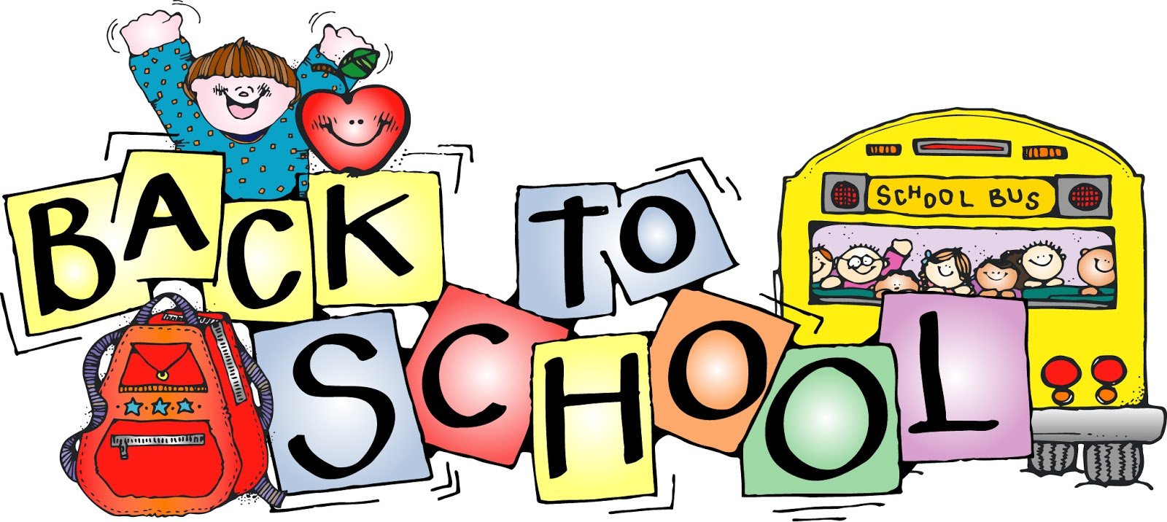August 2018

